

Student Name……………………………………

FURTHER MATHEMATICS

TRIAL EXAMINATION 1

2011

Reading Time: 15 minutes
Writing time: 1 hour 30 minutes

Instructions to students
This exam consists of Section A and Section B.
Section A contains 13 multiple-choice questions from the core, 'Data Analysis'.
Section A is compulsory and is worth 13 marks.
Section B consists of 6 modules each containing 9 multiple-choice questions. You should choose 3 of these modules and answer every question in each of your chosen modules.
Each of the modules is worth 9 marks.
Section B begins on page 9 of this exam.
There is a total of 40 marks available for this exam.
Unless otherwise stated the diagrams in this exam are not drawn to scale.
Students may bring one bound reference into the exam.
An approved graphics or CAS calculator may be used in the exam.
An answer sheet appears on page 37 of this exam.
Formula sheets can be found on pages 35 and 36 of this exam.

This paper has been prepared independently of the Victorian Curriculum and Assessment Authority to provide additional exam preparation for students. Although references have been reproduced with permission of the Victorian Curriculum and Assessment Authority, the publication is in no way connected with or endorsed by the Victorian Curriculum and Assessment Authority.

© THE HEFFERNAN GROUP 2011
This Trial Exam is licensed on a non transferable basis to the purchasing school. It may be copied by the school which has purchased it. This license does not permit distribution or copying of this Trial Exam by any other party.

SECTION A

CORE: Data analysis

This section is compulsory.

The following information relates to questions 1 and 2.

The annual profit increases for ten companies are given below. The increases are expressed as percentages.

5 | 8 | 8 | 7 | 9
3 | 5 | 4 | 6 | 4

Question 1

The interquartile range (IQR) of these annual profit increases is

- 3
- 4
- 4.5
- 5
- 5.5

Question 2

This data can be best displayed using a

- bar chart
- histogram
- dot plot
- scatterplot
- parallel stem plot

The information below relates to questions 3 and 4.

Samples of a freshwater fish were taken upstream and downstream in a river. The weight (in g) of each fish was recorded and is displayed in the boxplots below.

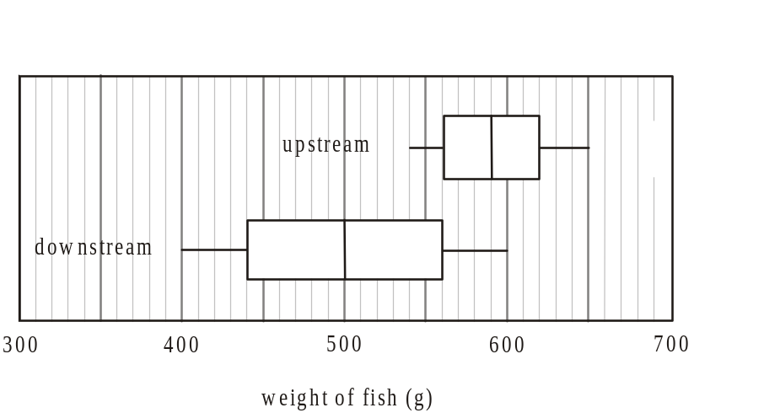

Question 3

From the boxplots, it can be concluded that the weights of the fish taken downstream are generally

- less than the weights of those taken upstream and less variable
- less than the weights of those taken upstream and more variable
- more than the weights of those taken upstream and less variable
- more than the weights of those taken upstream and more variable
- similar to those taken upstream.

Question 4

Using the 68 – 95 – 99.7% rule, for the sample of fish taken downstream, the standard deviation is closest to

- 35g
- 40g
- 45g
- 65g
- 85g

Question 5

The heights of a very large sample of women aged 80 years or more were recorded and were found to follow a normal distribution. The mean of the distribution was 164cm and the standard deviation was 4.5cm.
The percentage of these women with a height between 159.5cm and 173cm is closest to

- 47.5%
- 68%
- 75.5%
- 81.5%
- 95%

Question 6

A survey of 760 tertiary students was undertaken. The attendance category of each student together with their gender was recorded. The data is shown in the table below.

Attendance  category | Gender |  | Total
 | Male | Female
Part-time | 101 | 114 | 215
Full-time | 255 | 290 | 545
Total | 356 | 404 | 760

The percentage of full-time students who are female is closest to

- 38%
- 42%
- 47%
- 53%
- 72%

The following information relates to questions 7 and 8.

The weight (in kg) and age (in years) of ten residents at a nursing home were recorded.
The data is displayed on the scatterplot below. A regression line has been fitted by eye to the data.
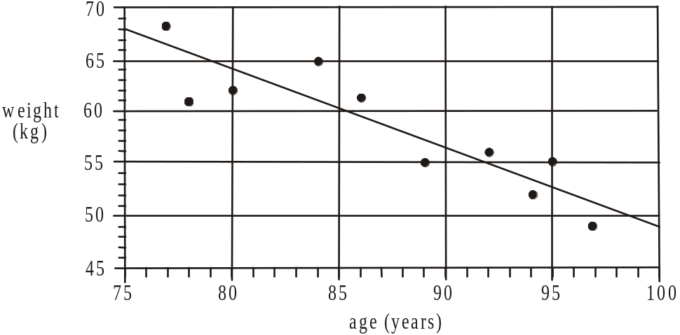

Question 7

The regression line predicts that the weight of an 84 year-old resident would be closest to

- 53kg
- 60kg
- 61kg
- 63kg
- 65kg

Question 8

The equation of the regression line that has been drawn is closest to

- 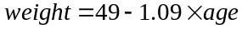
- 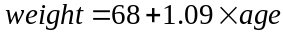
- 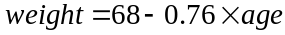
- 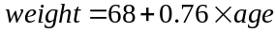
- 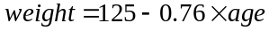

Question 9

The set of data shown in the table below is used to construct the scatterplot shown.

x | 2 | 4 | 6 | 8 | 10 | 12 | 14
y | 1 | 2 | 9 | 17 | 29 | 47 | 72

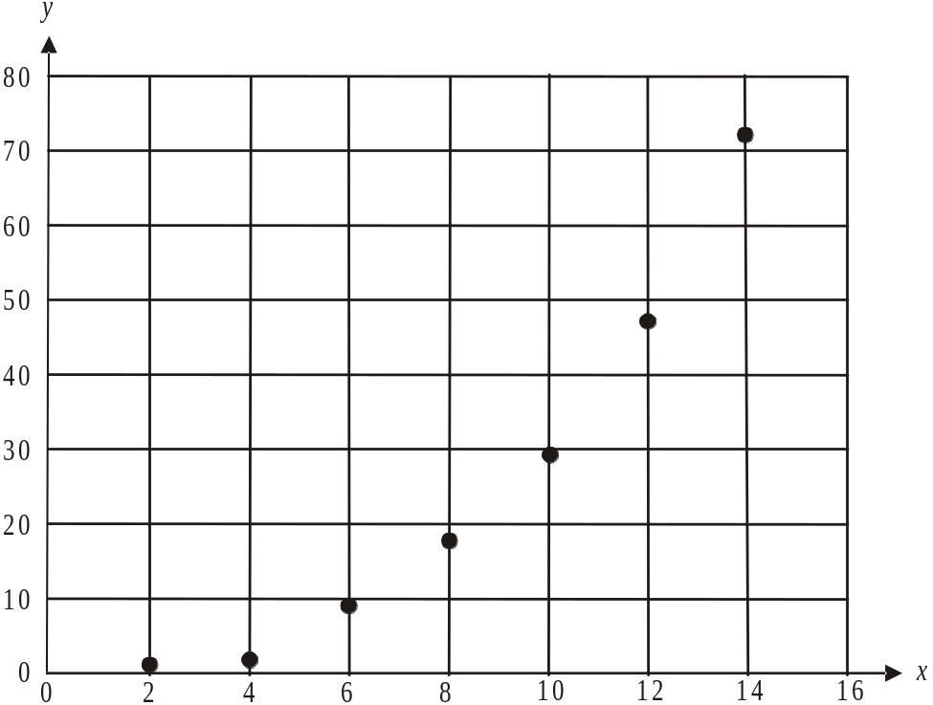

In an attempt to linearise the data, a reciprocal transformation is applied to the y-axis.
The independent variable remains x under this transformation. The least squares regression line that results from this transformed data has a gradient closest to

- 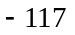
- 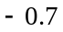
- 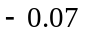
- 6
- 117
Question 10

A set of bivariate data with the variables x and y has x as the independent variable.
For this data,

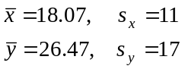

and Pearson’s correlation coefficient is equal to 0.9157.
The equation of the least squares regression line for this data is closest to

- 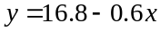
- 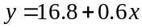
- 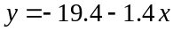
- 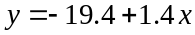
- 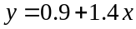

Question 11

A scatterplot showing bivariate data for the variables x and y is shown below.

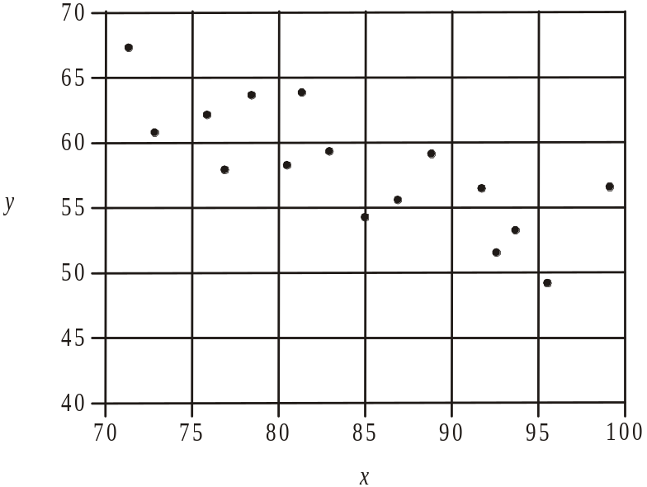

A regression line is to be fitted to the data using the 3-median method. The gradient of that line is closest to

- 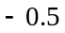
- 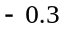
- 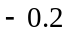
- 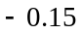
- 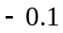

Question 12

The time series plot below shows the number of runners who ran in a half-marathon event each year between 2000 and 2012.

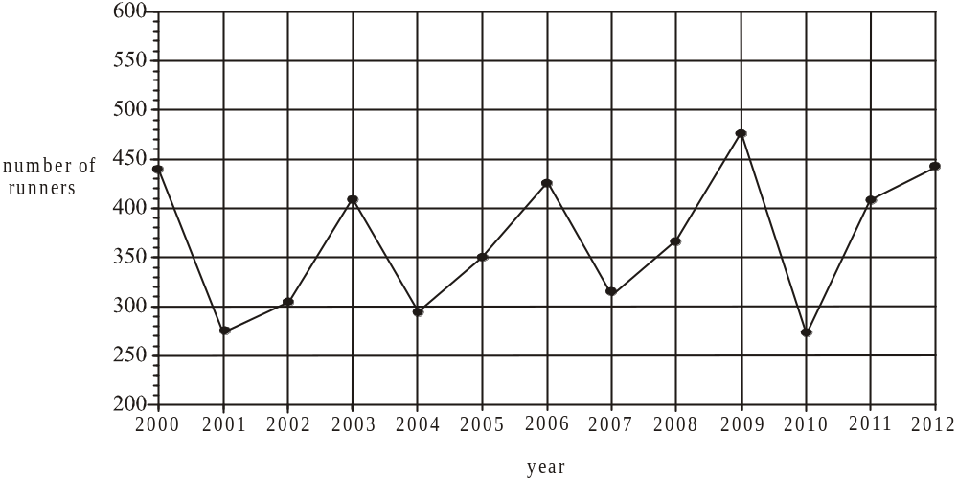

The time series plot shows

- a seasonal trend
- a downward trend
- a cyclical trend
- an upward trend
- no trend

Question 13

The table below shows the seasonal indices for the revenue of an outdoor café. The winter seasonal index has been left off.

Season | Summer | Autumn | Winter | Spring
Seasonal index | 1.42 | 0.86 |  | 1.18

When deseasonalised, the revenue of the café in winter 2010 was $42 500. The actual revenue for the café in winter 2010 is closest to

- $12 280
- $22 950
- $34 220
- $38 560
- $78 700
SECTION B

Module 1: Number patterns

If you choose this module all questions must be answered.

Question 1

Which one of the following sequences shows the first five terms of an arithmetic sequence?

- 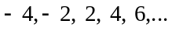
- 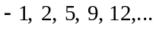
- 1, 2, 4, 8, 16, …
- 4, 2, 1, 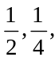 …
- 7, 4, 1, – 2, – 5, …

Question 2

The third term of the difference equation 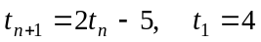 is

- – 3
- – 2
- 1
- 3
- 4.5

Question 3

The annual turnover of a small business follows a geometric sequence. In the first year the turnover was $100 000 and in the second year it was $110 000.
The turnover in the tenth year was closest to

- $190 000
- $200 000
- $235 795
- $259 374
- $273 823

Question 4

Three successive terms of a sequence generated by the difference equation with rule 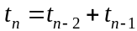 are 13, 21, x, …

The value of x is

- 26
- 29
- 31
- 34
- 42
Question 5

The sum of the infinite geometric sequence 120, -60, 30, -15, 7.5, … is

- 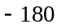
- 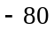
- 80
- 180
- 240

Question 6

The nth term of a sequence is defined by 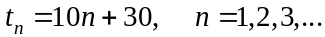
This sequence may also be generated by the difference equation

- 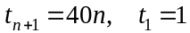
- 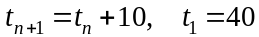
- 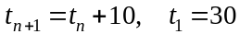
- 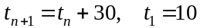
- 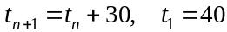

Question 7

Each week a stock manager in a warehouse accepts delivery of new stock into the warehouse and distributes stock from the warehouse to retail outlets.

The number of items of stock in the warehouse at the start of the nth week is given by 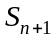 where 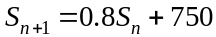.

Each week the stock manager therefore

- accepts delivery of 750 items of stock and distributes 80% of the number of items of stock present at the start of the week to retail outlets.

- accepts delivery of 750 items of stock and distributes 20% of the number of items of stock present at the start of the week to retail outlets.
- accepts delivery of 80% of the amount of stock present at the start of the week and distributes 750 items of stock to retail outlets.
- decreases the number of items of stock in the warehouse by 150.
- increases the number of items of stock in the warehouse by 600.

Question 8

A geometric sequence has a common ratio which is between zero and one.
For this sequence, the nth term is given by , and its graph could be

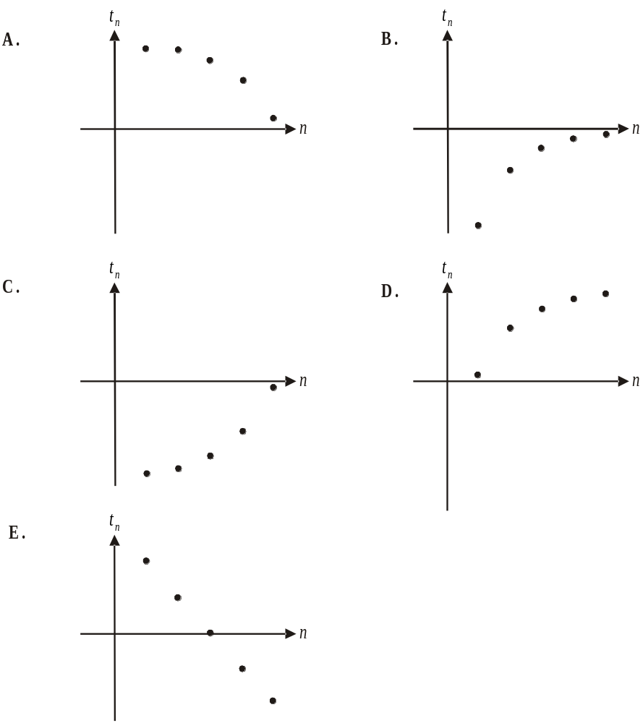

Question 9

A 595 metre long fence is built with 15 posts and has one of them at each end.
The distance between posts increases by 5 metres for each successive post as you move along the fence.
The largest distance, in metres, between posts for this fence is

- 7.2
- 10
- 55.7
- 67.2
- 75

Module 2: Geometry and trigonometry

If you choose this module all questions must be answered.

Question 1
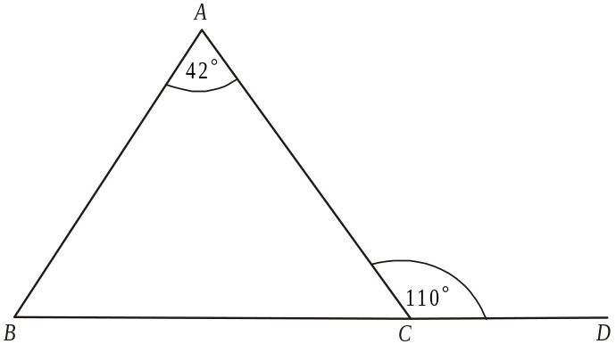

In the diagram above the size of angle ABC is

- 68°
- 70°
- 78°
- 112°
- 138

Question 2
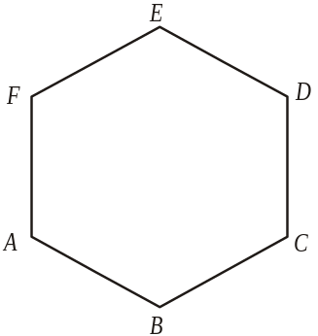

In the diagram above, ABCDEF is a regular hexagon.
The size of the obtuse angle CDE is

- 108°
- 110°
- 115°
- 120°
- 135°

Question 3

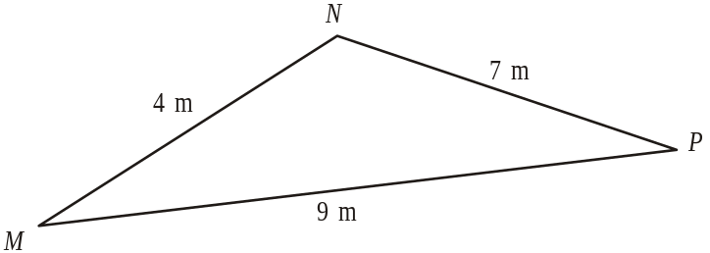

Using Heron’s formula, the area (in m²) of triangle MNP shown above, is given by

- 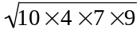
- 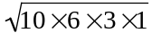
- 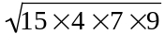
- 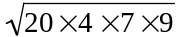
- 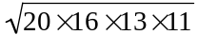

Question 4

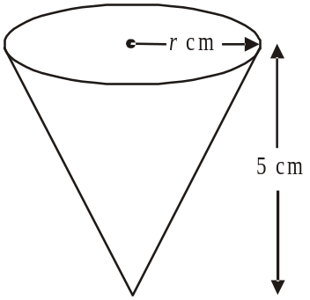

The solid cone shown above has a volume of 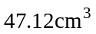.
The height of the cone is 5cm.
The radius r, in cm, of the top face of the cone is closest to

- 1.8
- 2.1
- 3
- 9
- 9.4
Question 5

A vendor sells rice in small and large containers of similar shape. The height of a small container is 4cm and the height of a large container is 5cm.
The volume of the large container is 937.5cm³.
The volume, in cm³, of the small container is

- 480
- 540
- 600
- 750
- 840

Question 6

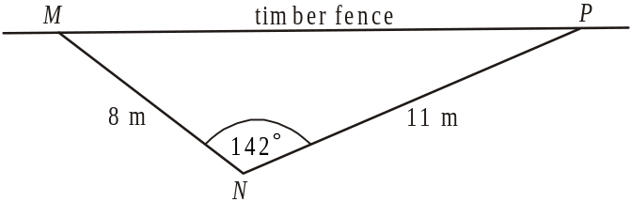

A triangular shaped chook pen has two sides MN and NP, made of wire netting where 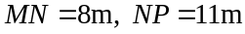 and angle 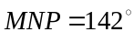.
The third side, MP, is formed by a timber fence of length, in metres, closest to

- 13
- 14
- 16
- 18
- 29

Question 7

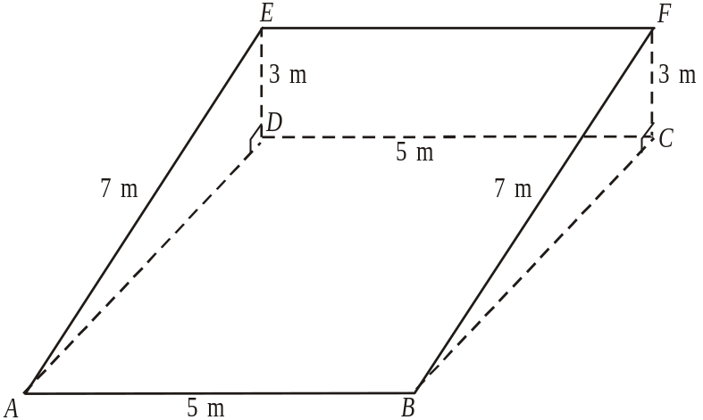

In the right-triangular prism ABCDEF, shown above, .
The size of angle CAF is closest to

- 2.3°
- 19.2°
- 20.4°
- 37.8°
- 69.6°

Question 8

On a training exercise, an army truck leaves its starting point and travels 4km on a bearing of 060°. It then changes direction and travels on a bearing of 130° and stops when it is due east of its starting point.
The direct distance, in km, of the truck from its finishing point to its starting point is closest to

- 2.4
- 2.9
- 3.1
- 5.1
- 5.8
Question 9

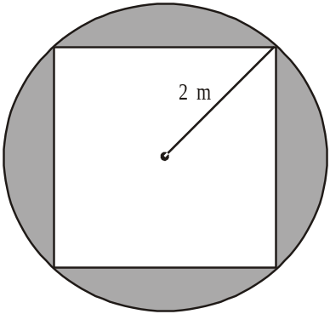

The diagram above shows the top of a very large circular table of radius 2m. The corners of a square tablecloth touch the edge of the table. The shaded region shows the table top which is not covered by the cloth.
The area of this shaded region, in m², is closest to

- 4.0
- 4.6
- 8.6
- 10.6
- 11.6

Module 3: Graphs and relations

If you choose this module all questions must be answered.

Question 1
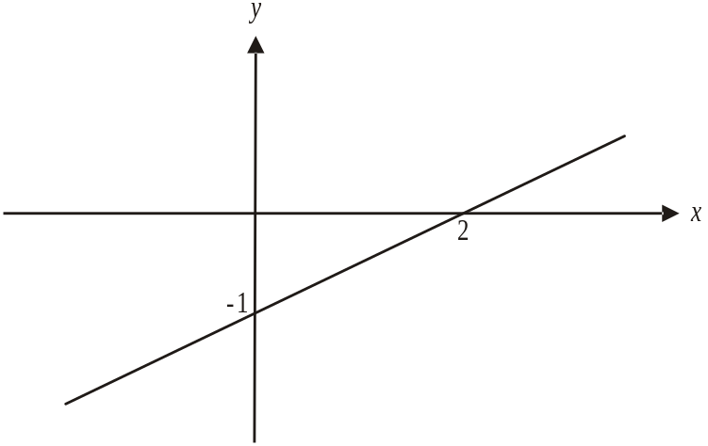

The line shown above passes through the points (0, −1) and (2, 0). The equation of this line is

- 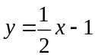
- 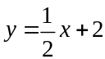
- 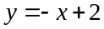
- 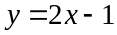
- 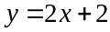

Question 2
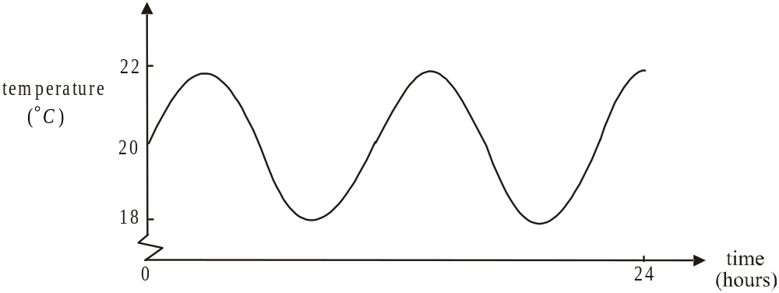

The graph above shows the temperature; in degrees Celsius, inside an incubator over a 24 hour period. The number of times the temperature was 21°C during this period was

- 0
- 1
- 4
- 5
- 6
Question 3

The delivery charges of a florist are based on the distance required to deliver the flowers.
The graph below shows these charges.

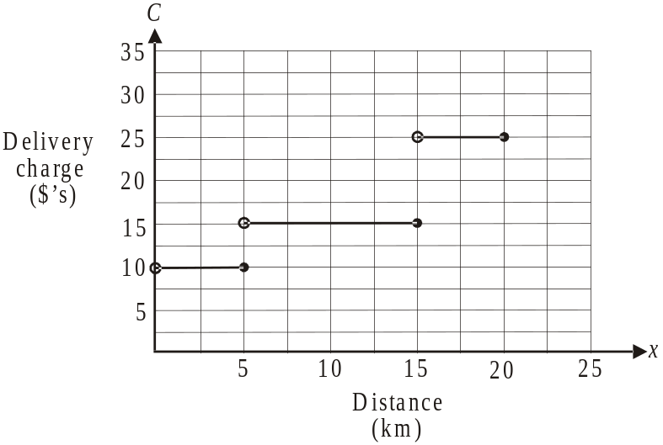

The rule that could be used to describe this graph is

- 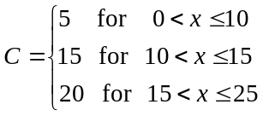

- 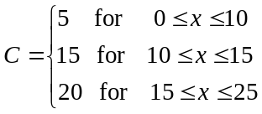

- 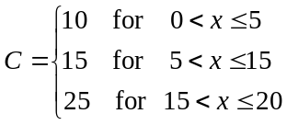

- 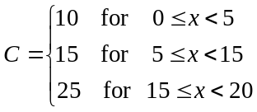

- 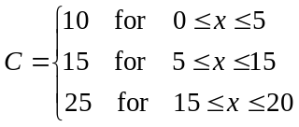
Question 4

The simultaneous equations

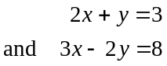

have a solution given by

- 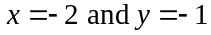
- 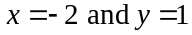
- 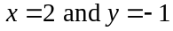
- 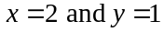
- 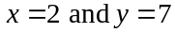

Question 5

The feasible region for a linear programming problem is shown below. The vertices are labelled A – E.

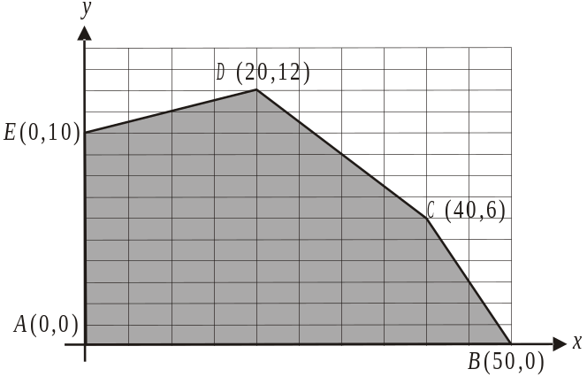

The minium value of the objective function 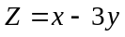 for this feasible region occurs at

- vertex A
- vertex B
- vertex C
- vertex D
- vertex E

Question 6

The graph of the relation 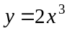 is shown below.

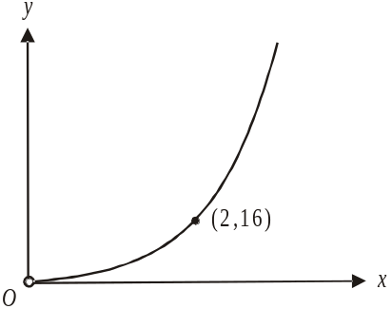

A graph that shows this same relationship is

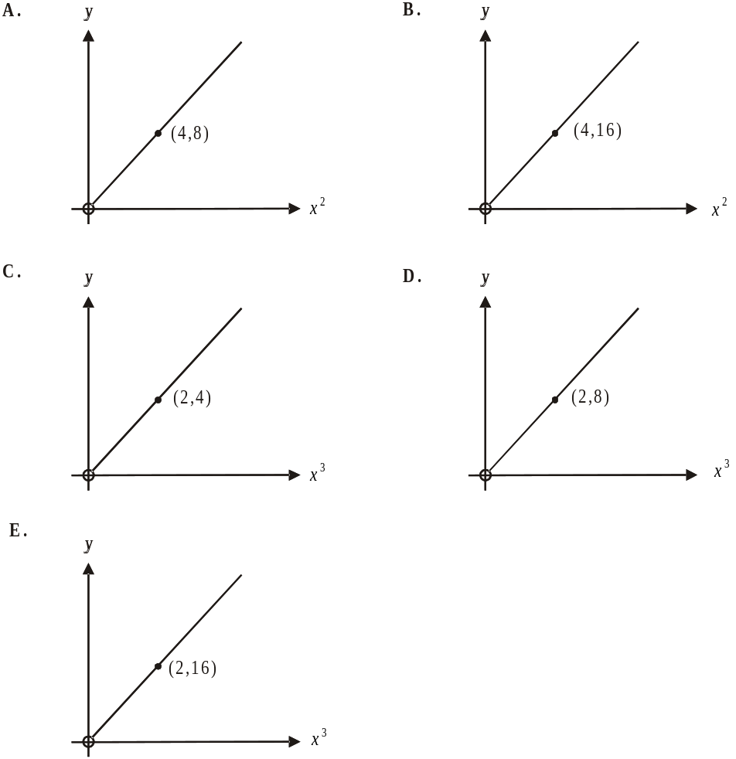

Question 7

The graphs of 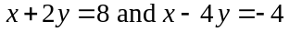 are shown below.
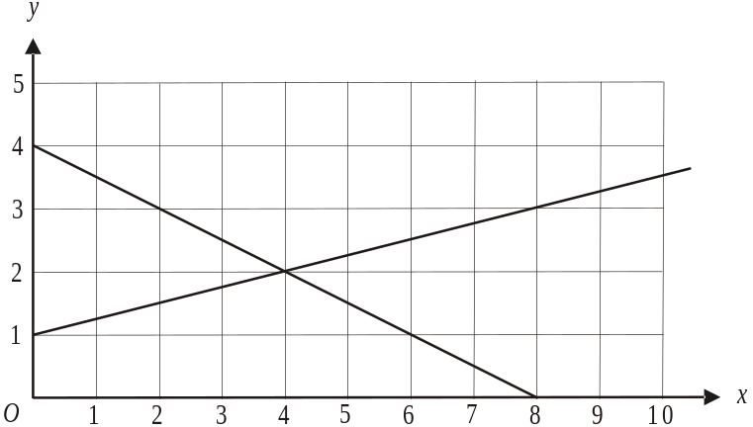

A linear programming problem has a feasible region described by the inequations

.

A point that lies in this feasible region is
- (1, 2)
- (2 ,4)
- (4, 1)
- (5, 2)
- (6, 1)

Question 8

Peter has two part-time jobs. He works at a café and earns $20 per hour and he works at a plant nursery where he earns $15 per hour.
He needs to earn a minimum of $400 per week from these two jobs and Peter likes to work at least twice as many hours at the café as he does at the plant nursery.
Let x = the number of hours per week Peter works at the café.
Let y = the number of hours per week Peter works at the plant nursery.
The inequalities that describe Peter’s situation are

- 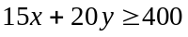
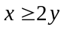

- 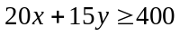

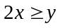

- 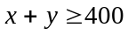
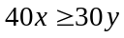

Question 9

The cost in dollars of producing cupcakes at a bakery is shown on the graph below.

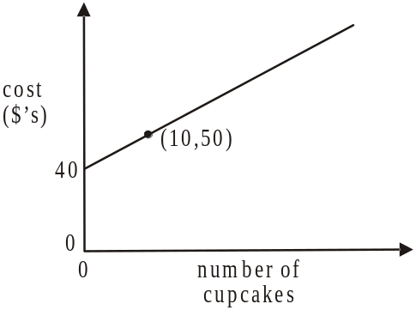

The bakery makes a profit of $20 when 30 cupcakes are sold. The number of cupcakes the bakery needs to produce to break even is

- 10
- 15
- 20
- 25
- 40

Module 4: Business-related mathematics

If you choose this module all questions must be answered.

Question 1

The sum of $990 was earned in simple interest when $6000 was invested for 3 years.
The annual interest rate for this investment was

- 2%
- 5.5%
- 6.1%
- 18%
- 49.5%

Question 2

A painting which had hung in an art dealers gallery, sold for $7500. The art dealer deducted a commission of 2% of this amount before giving the balance to the artist. The amount received by the artist was

- $150
- $1500
- $6000
- $7350
- $7500

Question 3

An amount of $450 000 is invested in an ordinary perpetuity which has an interest rate of 4.8% per annum. The investor is paid a fixed amount each month of

- $937.50
- $1800
- $3125
- $21 600
- $37 500

The information below relates to questions 4 and 5.

A coffee machine is purchased for $780 under a hire purchase agreement. A deposit of $200 was paid and weekly payments are made for 6 months. The flat rate of 6.2% per annum interest is charged.

Question 4

The weekly payments are

- $11.50
- $18
- $23
- $27.50
- $36

Question 5

The annual effective rate of interest under this hire purchase agreement is closest to

- 6%
- 10%
- 11%
- 12%
- 26%

Question 6

A fixed amount of money is invested in an account that earns compound interest calculated yearly.
No other transactions occur in this account.
A graph showing the amount in this account each year after the initial investment is made is

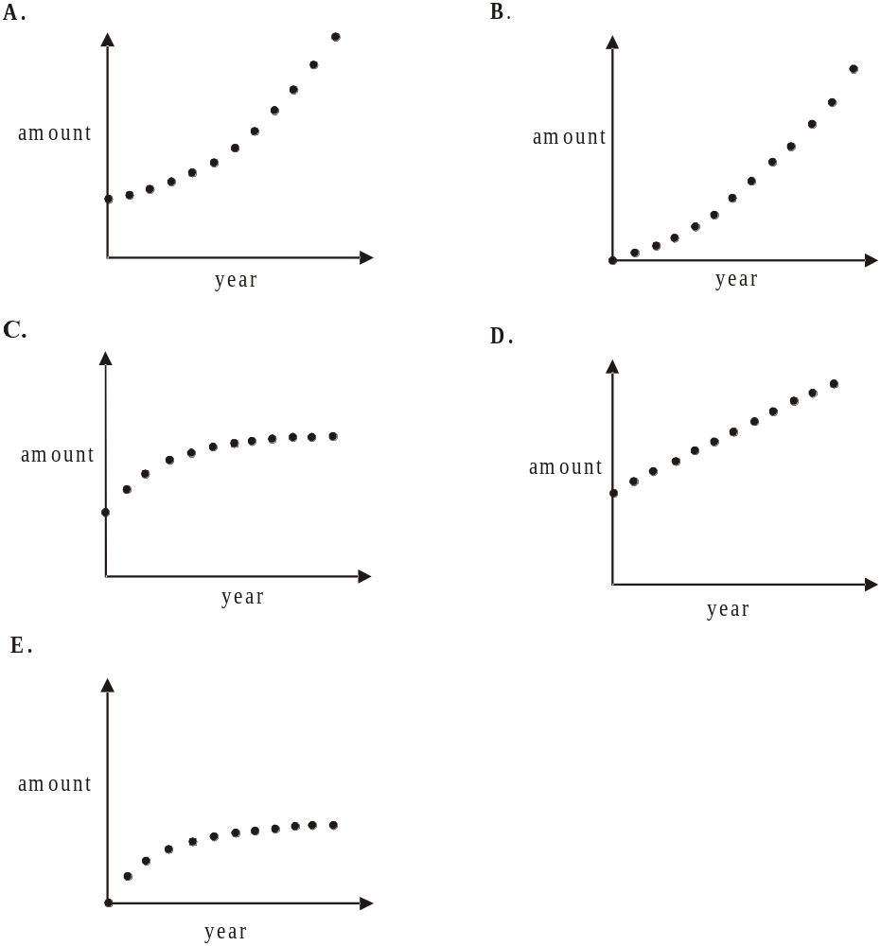

Question 7

Adriana invested $5000 at the start of 2007. The investment earned compound interest of 9% per annum compounding half-yearly. At the end of 2010 the value of Adriana’s investment was

- $5705.83
- $5962.59
- $6511.30
- $7110.50
- $97 704.40

Question 8

Jack takes out a reducing balance loan of $60 000.
After 4 years of paying monthly instalments of $700, Jack still owes $41 152.10.
The annual interest rate that Jack is paying on this loan is closest to

- 7.2%
- 9.2%
- 9.8%
- 12.4%
- 26.7%

Question 9

Carl took out a reducing balance loan for $22 000. Interest on this loan is calculated quarterly at the rate of 8.5% per annum.
Carl will make equal quarterly payments of $600 and then one final payment. This final payment will be less than $600.
The amount of principal Carl has left to pay after he makes his last payment of $600 is closest to

- $27
- $60
- $322
- $487
- $497
Module 5: Networks and decision mathematics

If you choose this module all questions must be answered.

Question 1
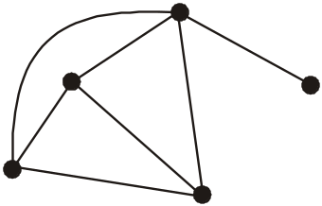

The sum of the degrees of all the vertices of the graph above is

- 5
- 7
- 12
- 13
- 14

Question 2


For the graph shown above, which one of the following is a spanning tree?
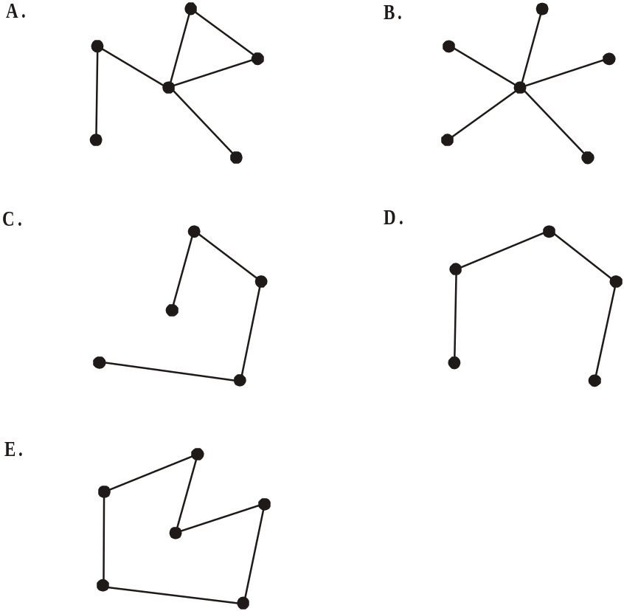

Question 3

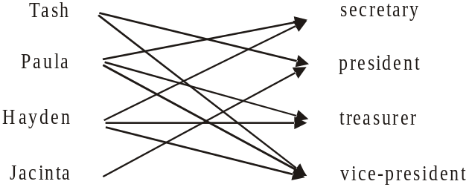

The bipartite graph above shows the four positions that need to be filled and the people who are prepared to fill them.

If each person takes on one role then a feasible allocation is

- Tash becomes President B. Tash becomes Secretary
Paula becomes Secretary Paula becomes Treasurer
Hayden becomes Vice-President Hayden becomes Vice-President
Jacinta becomes Treasurer Jacinta becomes President

C. Tash becomes President D. Tash becomes Vice-President
Paula becomes Secretary Paula becomes Treasurer
Hayden becomes Treasurer Hayden becomes Secretary
Jacinta becomes Vice-President Jacinta becomes President

E. Tash becomes Secretary
Paula becomes Vice-President
Hayden becomes Treasurer
Jacinta becomes President.

Question 4
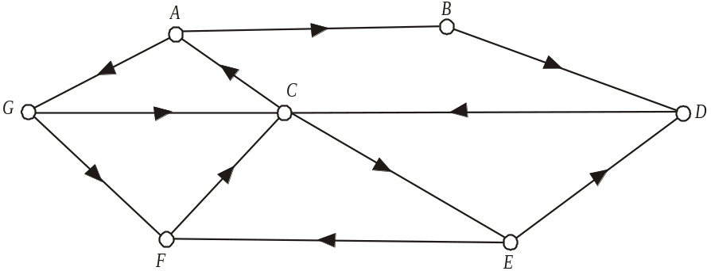

The graph above shows seven landmarks A – G and a series of one-way paths that connect them. Landmark B can be reached for example from landmark A.
The two-step reachability of landmark C is

- 3
- 4
- 5
- 6
- 7
The following information relates to questions 5 and 6.

Water flows from pond A to pond Z through a series of channels. The capacity (in megalitres per hour) of each channel together with the direction of flow is shown on the graph below. A cut has been made through the network and is shown below.
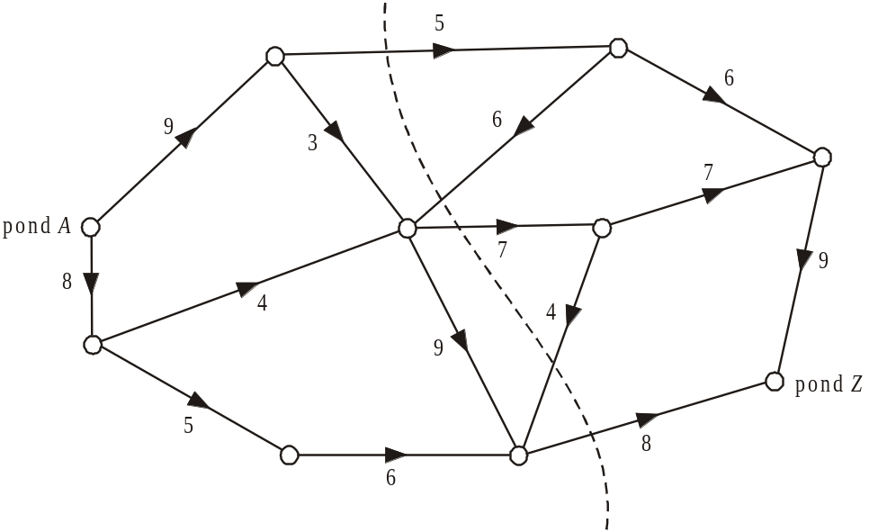

Question 5

The capacity (in megalitres per hour) of the cut shown is

- 10
- 14
- 16
- 18
- 20

Question 6

The maximum flow possible, in megalitres per hour, between pond A and pond Z is

- 16
- 17
- 18
- 19
- 20

Question 7


The graph shown above has

- 5 faces
- 6 faces
- 7 faces
- 8 faces
- 10 faces

The following information relates to Questions 8 and 9.

The network below shows the activities needed to complete a building project. The time, in weeks, required to complete each activity is also shown.

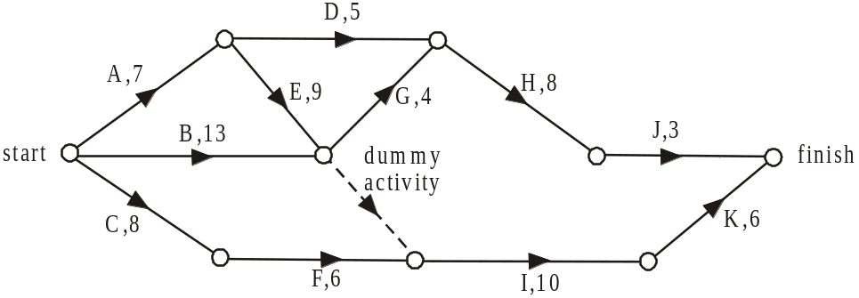

Question 8

The float time in weeks for activity B is

- 1
- 2
- 3
- 4
- 5

Question 9

The shortest time, in weeks, in which this project can be completed is

- 29
- 30
- 31
- 32
- 35
Module 6: Matrices

If you choose this module all questions must be answered.

Question 1

If 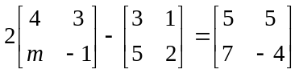 then m is equal to

- 1
- 3
- 5
- 6
- 8.5

Question 2

Let 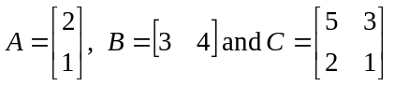.
The matrix product that is not defined is

- AB
- BA
- CA
- BC
- CB

Question 3

If 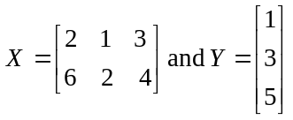 then the order of matrix XY is

Question 4

The determinant of the matrix 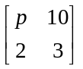 is equal to 4.
The value of p is

- 5
- 6
- 8
- 12
- 24

Question 5

At a deli, the total cost of one sourdough loaf and two baguettes is $10. The total cost of two sourdough loaves and three baguettes is $18. Let x be the cost of a sourdough loaf and let y be the cost of a baguette.
The matrix equation that can be used to find x and y is

- 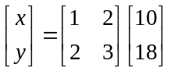

- 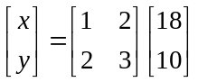

- 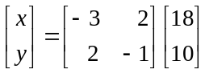

- 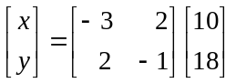

Question 6

In a junior football league, players pay annual registration fees. These fees; in dollars, for players in the under 10 (U10), under 12 (U12) and under 14 (U14) age groups for 2008, 2009 and 2010 are shown in the matrix below.

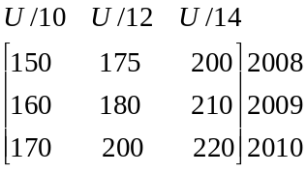

For 2008 to 2010 the number of players in each of the age groups U10, U12 and U14 at three different junior clubs; Highton (H), Briton (B) and Whiton (W) is shown in the matrix below.

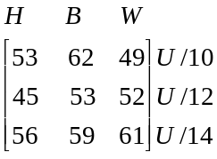

The total of the registration fees received in 2009 at the Whiton junior club for their U/10, U/12 and U/14 players is

- $27 815
- $30 010
- $31 570
- $31 850
- $32 150

Question 7

A company’s employees are located at four different offices A – D around the city.
The strategic plan is to relocate these employees according to the transition matrix T shown below.
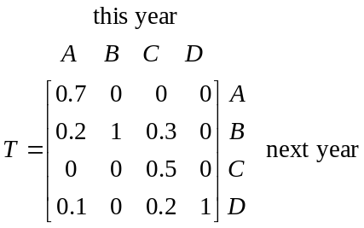

Over the long term, this strategic plan will see employees located at

- all 4 of these offices
- 3 of these offices only
- 2 of these offices only
- 1 of these offices only
- none of these offices.

Question 8

A chef produces one main course “special” each day.
He chooses either a pasta (P), risotto (R), fish (F) or chicken (C) dish for the specials.
The transition matrix T, below, shows how the chef determines which dish he will prepare from day to day.
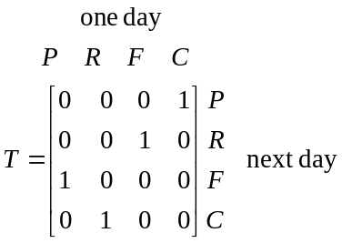

Which one of the following statements is not true?

- The chef never chooses the same dish two days in a row.
- One of the dishes will be a “special” once every four days.
- If the chef has a pasta one day then 2 days later he will have a risotto.
- If the chef has a risotto one day then 2 days later he will have a fish dish.
- A chicken dish never follows a fish dish.

Question 9

On a large passenger ship there are two restaurants; Waves and Swells.
On the first night at sea, 200 of the 600 passengers ate at Waves restaurant and the rest ate at Swells restaurant.
The staff have noticed over time that 70% of passengers who eat at Waves one night will eat there the next night and 80% of passengers who eat at Swells restaurant one night will eat there again the next night.
The number of passengers who eat at the Waves restaurant and the Swells restaurant on the second night at sea is given by the matrix product.

- 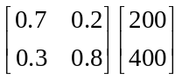

- 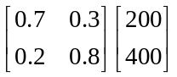

- 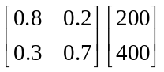

- 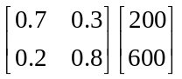

- 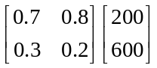

Further Mathematics Formulas

Core: Data analysis
standardised score: 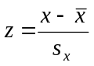
least squares line: 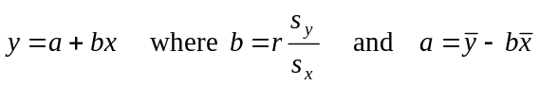
residual value: residual value = actual value – predicted value

seasonal index: seasonal index 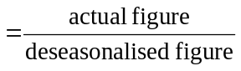

Module 1: Number patterns
arithmetic series: 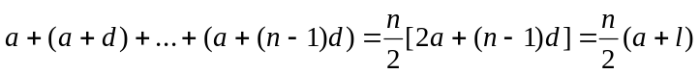
geometric series: 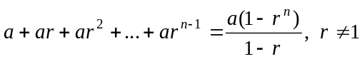
infinite geometric series: 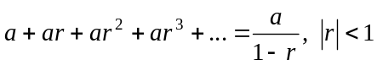

Module 2: Geometry and trigonometry
area of a triangle: 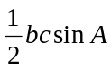
Heron's formula: 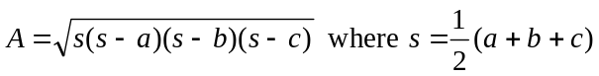
circumference of a circle: 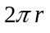
area of a circle: 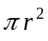
volume of a sphere: 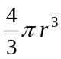
surface area of a sphere: 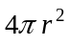
volume of a cone: 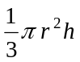
volume of a cylinder: 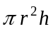
volume of a prism: 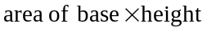
volume of a pyramid: 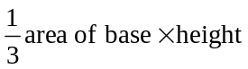

Reproduced with permission of the Victorian Curriculum and Assessment Authority, Victoria, Australia.
These formula sheets have been copied in 2011 from the VCAA website www.vcaa.vic.edu.au
The VCAA publish an exam issue supplement to the VCAA bulletin.
Pythagoras’ theorem 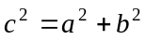
sine rule: 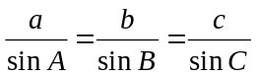
cosine rule: 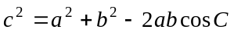

Module 3: Graphs and relations

Straight line graphs
gradient (slope): 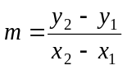
equation: 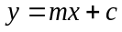

Module 4: Business-related mathematics

simple interest: 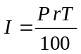
compound interest: 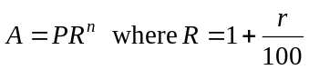
hire purchase: 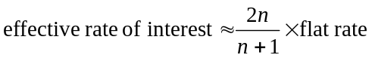

Module 5: Networks and decision mathematics

Euler’s formula: 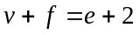

Module 6: Matrices

determinant of a 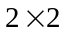 matrix 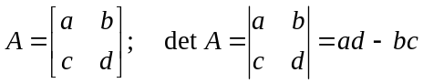
inverse of a matrix 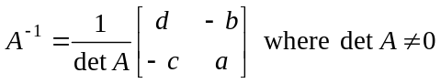

END OF FORMULA SHEET

Reproduced with permission of the Victorian Curriculum and Assessment Authority, Victoria, Australia.
These formula sheets have been copied in 2011 from the VCAA website www.vcaa.vic.edu.au
The VCAA publish an exam issue supplement to the VCAA bulletin.

